AGENDA OF THE HOLY EUROPE
Alliance of Patriotic Parallel Movements of European Folks (APP MEF)
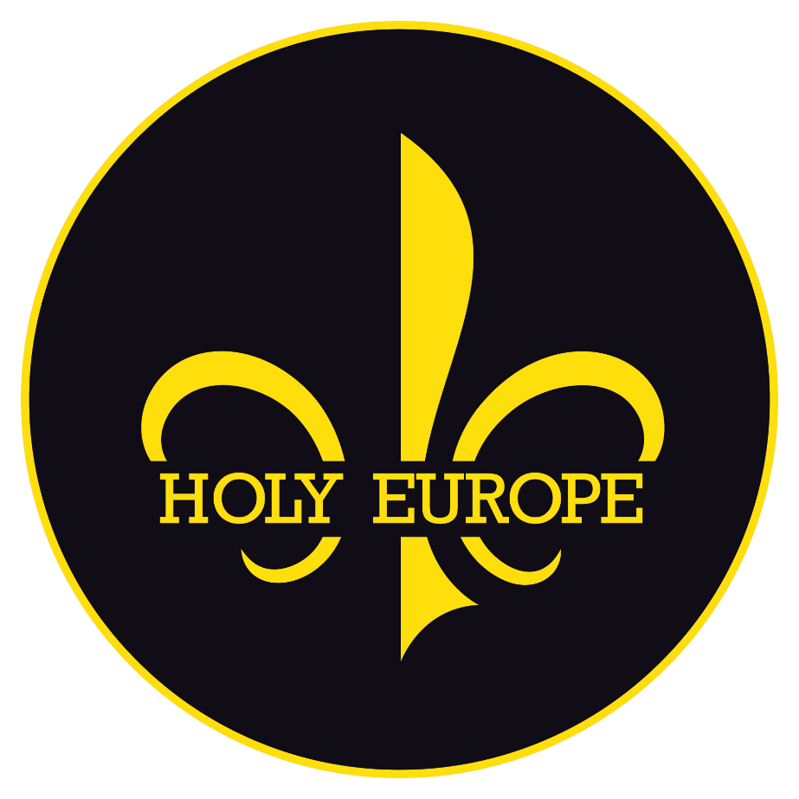
What is the idea of „Holy Europe“?!
That is an idea which imperatively demands re-Christianization of Europe (and its colonies) that is its peoples on the base of the confession of faith pre-1054. Why is the pre-1054 confession of faith important?! Because Europe was in spiritual unity then, but after the year 1054 began the intense decay of Europe, firstly on a spiritual level and then the decay process spilled over to all other levels. The idea of the „Holy Europe“ is standing on the realization that unifying Europe spiritually in the truth of the Holy Church is the absolute imperative and a prerequisite of every struggle. The idea of the „Holy Europe“ rejects the division of Europe on West and East, because today Christianization is needed by both since both West and East have abandoned Divine canons established by the Holy Spirit at the Ecumenical Councils of the Holy Fathers. Renewal of the spirit won’t happen without repentance and without true confession of faith and also without essential change of heart of the white man and his full devotion (through the way of piety and the correct way of living) to God and to the Holy Church. The idea of the „Holy Europe“ implies Christian fundamentalism which is the faith of the Church as its eternal foundation. “Holy Europe“ restores the archetype of the knight-priest in every white man and the archetype of the housewife-mother in every white woman. “Holy Europe“ also restores the organic principle of absolutist-class monarchy. In essence, our idea is performing the revision of everything from the time of the Renaissance to the current time.

The seven pillars of life and foundation of our struggle:

1. THE RESTORATION OF THE CHRISTIAN EUROPE
2. THE PRESERVATION OF BLOOD (RACIAL-BIOLOGICAL IDENTITY)
3. THE RESTORATION OF PATRIARCHY (SEXUAL IDENTITY)
4. THE DOCTRINE OF ATTACK (CONQUEST STRATEGY)
5. THE RESTORATION OF THE PRINCIPLE OF MONARCHY (ABSOLUTIST-CLASS)
6. THE RESTORATION OF THE CRUSADE KNIGHTHOOD (MORAL IDENTITY) AND MILITARISM
7. THE FORMATION OF INDEPENDENT COMMUNITIES ON THE FREE LIVING SPACE

The thirteen damnations of Europe and thirteen seeds of satan:

1. GODLESSNESS (ATHEISM).
2. ECUMENISM AND HIPPIE-CHRISTIANITY (the heresy propagated by the ecumenist sect)
3. FATALISM AND DEFEATISM
4. LIBERALISM AND DEMOCRACY
5. LEFTIST IDEAS (ANARCHISM, MARXISM, COMMUNISM, BOLSHEVISM…)
6. INDIVIDUALISM AND CONFORMISM
7. PROJECTED PSEUDO-STATE NATIONALISM AND PATRIOTISM
8. PACIFISM, INTEGRAL INERTNESS AND THE CULT OF DEFENSE
9. INTERRACISM AND MULTICULTURALISM
10. REPUBLICANISM
11. NEOPAGANISM
12. GLOBALISM
13. IDOLATRY

What is the „Parallel System“?!

There are three main types of struggle (against the official system) and those are:
1. THE SYSTEMIC STRUGGLE
2. THE ANTI-SYSTEMIC STRUGGLE
3. THE PARALLEL SYSTEM (hereinafter referred to as “PS”).
The PS rejects the systemic struggle and that is the struggle which for the goal has to change the existing system, to “better” it or replace it with some other option (essentially of the same system) through the work in political parties, standing for democratic elections and voting, syndical struggle and strikes, citizen disobedience and public expression of dissatisfaction, marches and protest rallies, work in nongovernmental organizations…
PS also rejects the anti-systemic struggle and that is the struggle that for the goal has to violently destroy or change the existing system (through revolutions, uprisings, coups, overthrowing…) or replace it with some other option (of essentially the same system). Why? Because both the official system and its possible alternative – the anti-system is just a theatre curtain behind which the true government is on the stage.
Everything is a farce and an empty shell filled only with projected content which for the goal has to deceive the masses, manipulate and use it. All movements and political parties want the power and only the PS doesn’t want the power, not even over a single trash bin in the democratic system. Why? Because democracy is a negation of the authority. The PS doesn’t want to take a part in this because those who control the system and the anti-system haven’t left a single possibility to make an essential change. The democratic system is a delayed-action political virus which as its goal has the destruction of the state and turning it into an O.Z. (Occupation Zone) which is the maid of the New World Order – the antichrist's anti-empire.
The creation of the “Parallel System” is inevitable for all God-loving, freedom-loving and truth-loving people. A system that would work parallel to the official system and would never clash with it. Why?! Firstly, because there’s no purpose in that. Namely, democratic quasi-state and liberal society, family and individual are gravely ill. The democratic „state“ (its liberal society, feministic negation of family and insane¹ individual) is like a cancer patient with metastasis whose organism is falling apart. There’s no purpose and no effect in treating such a patient. Even though the official system is our enemy, there’s no point in fighting against it. The society is a zombie – a dead man walking. Secondly, we shouldn’t clash with the official system because it is repressive and owns the instruments of force (police, courts, army, security services…) which can hurt us indeed, and all that for no purpose.

What is “Alliance of Patriotic Parallel Movements of European Folks” (hereinafter „Alliance“)?!

Those are all movements, groups, and individuals of the European peoples (and their colonies) that accept the further rules:
1. A member of the Alliance can be every patriotic movement, group, or individual of all peoples of Europe that is colloquially Christian, under the condition that all other members of the Alliance are fine with that.
2. Membership in the Alliance is voluntary.
3. Full integrity is guaranteed to all members of the Alliance.
4. By being members of the Alliance, members do not change their ideologies and stay fully sovereign in their actions, which means that they can wage a systemic or anti-systemic fight according to their own programs.
5. By being members of the Alliance, members accept the concept of the „Parallel System“ with the idea of the „Holy Europe“ and with that, they practically upgrade (enrich) their own ideologies.
6. No member of the Alliance can condition another member of the Alliance with any kind of demands such as recognition of its ideological views, political stances, or interests.
7. Members are not obliged to cooperate with other members of the Alliance nor necessarily to support them.
8. What unites the Alliance is this agenda and its expanded edition in the book „The Third Way“.
9. The Alliance as a whole or some of its members can initiate joint initiatives and actions using the name and the idea of the Alliance independently of those members that are not taking part in those initiatives and actions.
10. This agenda is the only foundation for the eventual changes and additions regarding the Alliance.

organization |  | Alliance of  Patriotic Parallel Movements
 |  | оf European Folks
group

 |  | 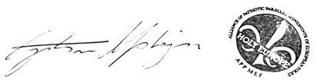
individual

